**TOPIC: VIRTUAL LEARNING MANAGEMENT SYSTEM WITH VIRTUAL REALITY**

**Post Module Assignment**

|  |  |
| --- | --- |
| Module Title | User Centred Design |
| Module code | COM7034M |
| Student Name | Shamsiya Theruvathu Veettil Shamsudheen |
| Student ID | 220156284 |
| Student Email | Shamsiya.theruvath@yorksj.ac.uk |
| Word Count | 4484(4106 excluding Reference) |
| Submission Date | 13th December 2022 |

TABLE OF CONTENTS

1INTRODUCTION 2

**1.1 Scope** 2

**1.2 Features/Tools** 3

**1.3 Techniques** 3

**1.3.1** **Adaptive learning** 3

**1.4 Approach** 4

2REQUIREMENTS 5

**2.1 Existing Systems** 5

**2.1.1** **Limitations of Existing System** 5

**2.2 Proposed System** 6

**2.3 Feasibility Study** 6

**2.4 Functional Requirement** 6

**2.5 Non-Functional Requirement** 8

**2.6 System Requirements** 8

**2.6.1** **Hardware Requirements** 8

**2.6.2** **Software Requirements** 9

3PROTOTYPE DESIGN 10

**3.1 Methodology** 10

**3.1.1** **Approach Used** 10

**3.2 User Experience** 10

**3.3 System Architecture** 11

**3.4 Wireframe** 12

**3.5 Use Case Diagram** 13

**3.6 Sequence Diagram** 14

**3.7 ER Diagram** 15

**3.8 Activity Diagram** 16

**3.9 Class Diagram** 18

**3.10 User Interface** 19

**3.10.1** **Server Connection** 19

**3.10.2** **Website** 20

**3.11 TESTING** 25

4CONCLUSION 26

5BIBLIOGRAPHY 27

# **INTRODUCTION**

Virtual learning, also known as online or distance education, refers to the use of digital technology to facilitate the delivery of educational content and communication between learners and educators who may be located remotely. It can take many forms, including online courses, webinars, virtual classrooms, and self-paced learning materials. Virtual learning offers several benefits: convenience, flexibility, cost-effectiveness, and personalized learning experiences. It is becoming increasingly popular and used by various educational institutions, businesses, and other organizations to deliver education and training to students and employees. A virtual learning management system (VLMS) is a software application or web-based technology used to plan, implement, and assess a specific learning process. Typically, an LMS allows educators to create and deliver content, track student progress, and manage student information. An LMS can be used for various purposes, including delivering online courses, conducting virtual classrooms, and providing resources for self-paced learning. Educational institutions, businesses, and other organizations are increasingly using virtual learning management systems to provide flexible and convenient learning opportunities to students and employees (Aziah Alias & Marzuki Zainuddin, 2005). They offer a range of benefits, including the ability to access learning materials from any location with an internet connection, support for collaborative learning, and the ability to track and assess student progress.

This coursework aims to develop a prototype design for learning using the virtual learning management system and implement virtual reality (VR) and augmented reality (AR) for a futuristic approach.

## **Scope**

The project aims to address the issue of computer science students needing to be adequately prepared for the job market by improving current learning and teaching methods. This may involve introducing new educational techniques, offering more practical and hands-on learning opportunities, or increasing collaboration between academia and industry to ensure students gain in-demand skills. The project plans to develop a tutorial web application using advanced computer technologies to achieve these goals. The application will include features such as a centralised database of course materials, virtual meeting spaces for students and tutors, and the ability to upload PowerPoint slides and PDFs. Additionally, the project plans to incorporate virtual reality (VR) learning to provide students with an immersive and interactive educational experience. VR learning can benefit young children and help students learn independently. Overall, the goal of the project is to improve the academic experience of university students and increase the pool of qualified candidates for computer science jobs.

## **Features/Tools**

Virtual Learning Management Systems (VLMSs) are online platforms that provide tools and features to support online education and training delivery and management. These tools and components used in this application include course creation tools, learner tracking and assessment tools, communication tools, content management tools, and student support resources. Hence the design principle also aims to collaborate with virtual reality systems to use computer-generated simulations of 3D environments that can be interacted with in a seemingly natural or physical way by the user. VR systems include head-mounted displays (HMDs), handheld controllers, tracking sensors, audio systems, and haptic devices to create an immersive experience.

## **Techniques**

Online education platforms can use various techniques to support the delivery and management of online courses and training programs, including blended learning, self-paced learning, gamification, collaborative learning, adaptive learning, synchronous learning, mobile learning, project-based learning, and flipped classrooms. These techniques can be used alone or in combination to create an engaging and practical learning experience for students.

The techniques used in this prototype are as follows:

### **Adaptive learning**

This technique uses data and algorithms to personalise the learning experience for each learner by adapting the content and pace of the course based on the learner's progress and needs. Adaptive learning can be particularly effective in VLMS, as it allows learners to receive customised support and guidance as they progress through the course. This approach can benefit learners who may need extra support or struggle with certain concepts.

This technique gives a reasonable enrolment rate and reduces the unutilised learning after enrolling by learners, as inbuilt content can be tedious, thereby increasing the dropout percentage. This learning method can be combined with virtual reality by analysing it in detail.

## **Approach**

User-centred approaches in education aim to design learning experiences tailored to individual students' needs, preferences, and abilities. These approaches include personalized learning, student choice, frequent feedback and support, and multimedia content. The goal is to create a more personalized, engaging, and effective learning experience for students through technology and multimedia content. A model for educational design is called Verhagen's model and is being used to design and develop a virtual learning module (Arsyad, et al., 2017). This model comprises five phases: analysis, design, development, implementation, and evaluation.

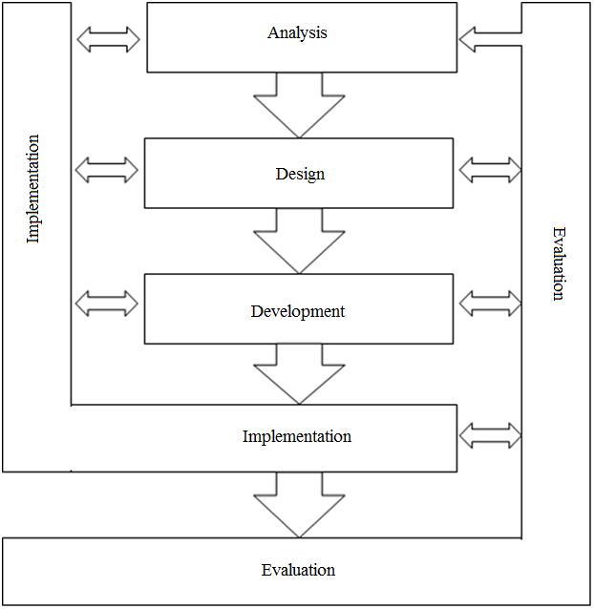

**Fig 1: Verhagen's model**

(Source: Internet)

# **REQUIREMENTS**

The first step in the process was identifying the e-learning platform's target audience. In this case, the target audience was high school and college students interested in learning about various subjects (individuals of different genders and ages, as well as individuals with diverse backgrounds and levels of education). In addition to gathering requirements from the participants, also conducted a review of existing e-learning platforms to identify best practices and features that could be incorporated into the design of this platform.

## **Existing Systems**

In 2020, Eze conducted a study to evaluate existing e-learning applications and design a prototype system with an improved communication interface, security, and system upgrade capabilities. They used a firewall system to enhance security (Eze, 2020). The result of their work was a prototype system with these improved features. In the study by Mutiawani & Juwita (2014), the authors addressed the issue of university students needing help understanding basic programming logic. They used the waterfall software model and HTML, CSS, and JavaScript to develop course materials divided into three categories: multimedia video, image, and program code (Viska Mutiawani, 2015). One gap identified in this study is that the method of programming used may need to be updated as the programming world is constantly evolving.

### **Limitations of Existing System**

There are several limitations of existing Virtual Learning Management Systems (VLMS):

* Accessibility: Some VLMS platforms may not be accessible to all users, particularly those with disabilities, due to the lack of support for assistive technologies or limited compatibility with specific devices.
* Scalability: Some VLMS platforms may need help handling large numbers of users or courses, leading to performance issues and a poor user experience.
* Cost: Some VLMS platforms may be expensive for schools or organizations to implement, creating financial barriers to adoption.
* User adoption: Some users, particularly older learners, may resist using new technology or struggle to adapt to the virtual learning environment.
* Quality of course materials: The quality of the subject materials can vary significantly on VLMS platforms, with some courses needing to be better organized or updated.
* Limited interactivity: Some VLMS platforms may need more interactive features or may provide a more engaging learning experience.

## **Proposed System**

The prototype application or device chosen for this coursework is a virtual reality (VR) headset for immersive learning. The VR headset is a wearable device that allows the user to experience a computer-generated 3D environment as if they were physically present. The VR headset for immersive learning is intended to provide learners with a more interactive and engaging learning experience. It allows learners to explore virtual environments and interact with virtual objects and characters more effectively. The VR headset also enables educators to create interactive simulations and virtual scenarios that can be used as educational tools. This assignment explores the design of a VLMS prototype, including the key features and functionality necessary to support effective online learning. Also, consider how the prototype design could be improved and enhanced over time based on feedback and data from system users. Augmented and virtual reality learning can revolutionize the field of education. Yet, they still need to be explored by popular e-learning platforms such as Byjus and Unacademy. These technologies offer immersive and interactive experiences that can enhance how we learn and understand concepts. The traditional method of watching videos or lectures may be enhanced with AR and VR in education. The incorporation of these technologies is a step towards a more comprehensive and engaging learning experience in the digital realm.

## **Feasibility Study**

The ideal e-learning management system should be cost-effective, offer support and training, and be easy to use, scalable, and sustainable. These factors are essential for ensuring student success and maximizing the value of the VLMS within the overall learning infrastructure of an institution. The LMS should provide a virtual learning community with resources for students and faculty and an online help desk with multiple support options. It should also be user-friendly and able to handle a large volume of active courses and users while adapting to future growth and development. Ensuring the sustainability of the LMS is crucial for the continued success of the virtual learning environment.

## **Functional Requirement**

Some functional requirements for the proposed system in an e-learning platform are:

|  |  |
| --- | --- |
| Students | **Registration:** The platform should allow users to create an account and provide their personal information, such as name and email address, during the registration process.  **Login**: The platform should allow registered users to log in to their accounts using their credentials.  **Profile update**: The platform should allow users to update their profile information, such as their name and email address.  **Dashboard Access:** The system should allow users to easily access the dashboard and find necessary learning materials. |
| Tutor | **View:** The system must allow users to view students’ information.  Add: The system should allow users to view lecture details. And permit users to publish lecture materials.  **Projects:** The system should allow the user to publish assignment submission information and control upload details.  **Feedback**: The system should allow the user to publish marks and feedback for the assignments |
| Administrator | **Control:** The system should allow the user to manage user accounts.  **Backup:** The system should permit the user to accomplish system backups.  **Record**: The system should allow the user to keep records, update lecture calendar details |

## **Non-Functional Requirement**

Some additional non-functional requirements for an e-learning platform include the following:

* Performance: The platform should be able to handle a large number of users and courses without experiencing performance issues or delays.
* Scalability: The platform should handle increasing users and courses without requiring significant additional resources.
* Security: The platform should have robust security measures to protect user data and prevent unauthorized access.
* Usability: The platform should be easy to use and navigate for learners and instructors.
* Accessibility: The platform should be accessible to all users, including those with disabilities, and support assistive technologies.
* Compatibility: The platform should be compatible with and accessible on web devices.
* Integration with other tools: The platform should be able to integrate with other learning tools and platforms, such as learning management systems and e-book readers.
* Customization: The platform should allow users to customize their learning experience by adjusting the platform's appearance and layout.
* Productivity: The system should be able to support a large number of concurrent users or sessions without experiencing any performance issues or delays.

Based on the analysis of existing systems and the review of similar platforms, the requirements gathered will be incorporated as features in the proposed e-learning platform. This platform is expected to improve the efficiency of the learners and tutors and enhance the value of its teaching process.

## **System Requirements**

System requirements are the necessary components for a client to install and use the web application without difficulties. The minimum requirements for hardware, software, and other essential tools or equipment have been identified to ensure a smooth installation. The minimum requirements are as follows:

### **Hardware Requirements**

* A computer with at least 256 MB random access memory and 1 gigabyte of a processor is preferred.
* Internet speed of minimum 5Mbps.
* Memory storage required a minimum of 6 gigabyte.

### **Software Requirements**

* Works well with almost all browsers but when tested the VR is not working with Google Chrome but suites well with the Safari browser.
* MacBook OS, Linux, and Windows are suited to the application developed.
* Used XAMPP for servers, Visual Studio code for scripting (HTML, PHP, JavaScript)
* SQL is used for the database in PhpMyAdmin through localhost.
* UML Diagrams were drawn with the help of the draw.io website.
* Virtual Reality 3D model created using the EchoAR API and JavaScript.
* Prototype design for the wireframe was done with the help of Canva

# **PROTOTYPE DESIGN**

## **Methodology**

The system is designed to meet the needs of three primary users: the administrator, the instructor, and the student. Each user has specific tasks and roles within the system, with the administrator having the most privileges, the instructor having intermediate benefits, and the student having minor rights. The functional prototype method, which involves the creation of an operating, interactive version of the product using actual code or other materials, is used here. The prototype overview is created as sprints in the Agile model, where the project has different development stages. Due to time constraints, the entire model was not built but created an overall basic structure. Hence, this project aims to develop augmented and virtual reality modules that enhance the learning experience by making it more interactive and engaging. These modules will cover complex subjects like chemistry, biology, and physics and include visualizations and real-life models to aid understanding. In addition, students can explore virtual representations of space, monuments, and the solar system, making e-learning more exciting and engaging. Overall, incorporating AR and VR technology into e-learning can improve the way we learn and understand concepts significantly (Salza, 2019).

### **Approach Used**

The iterative approach has been chosen for this project because it allows for flexibility in the face of changing requirements and the possibility of new requirements emerging during the development process. This approach also enables the construction of a working model of the proposed system at early stages, allowing for testing and incorporation of user feedback before full deployment. Additionally, the iterative approach will enable lessons learned and experiences from previous steps to be applied to subsequent iterations(Tsai, et al., 1997). This approach is particularly suitable for this project as the prototype for the virtual learning environment (VLE) is relatively simple and is being developed over a limited period, with less emphasis on comprehensive planning and strict structure.

## **User Experience**

The Five Planes of user-centred design is a framework developed by Jesse James Garrett (Garrett, 2002) concerning online learning are:

* The Surface Plane: This plane focuses on the visual design and aesthetics of the e-learning interface. It includes elements such as the layout, colour scheme, typography, and overall look and feel of the interface.
* The Skeleton Plane: This plane focuses on the structural and navigational elements of the e-learning interface. It includes features such as the layout of the content, the organization of information, and the navigation menu.
* The Scope Plane: This plane focuses on the content and functionality of the e-learning interface. It includes the course material, interactive elements, and assessments.
* The Strategy Plane: This plan focuses on the overall goals and objectives of the e-learning interface. It includes elements such as the learning objectives, instructional design, and target audience.
* The Support Plane: This plane focuses on the resources and support provided to learners during their e-learning experience. It includes technical support, instructional design support, and learner support services.

## **System Architecture**

A three-tier architecture for an e-learning system using virtual reality (VR) contains the following layers:

* Presentation layer: This is the VR interface that the user interacts with. It could include a VR dashboard, a course catalogue, and a virtual classroom.
* Logic layer: This layer would contain the business logic of the e-learning system, including processes such as enrolling in courses, tracking progress, and calculating grades. It would communicate with the database layer to store and retrieve data.
* Database layer: This layer would be responsible for storing and retrieving data from the database, such as course information, student records, and assignments. It could also include any necessary VR-specific data, such as VR environments and assets.

By dividing the e-learning system into these three layers, it becomes easier to develop and maintain the system, as changes to one layer do not necessarily affect the other layers. This also allows for better scalability and flexibility, as different components can be modified or replaced without affecting the entire system.

## **Wireframe**

A wireframe is a low-fidelity visual representation of a website or app's user interface (UI). It is a blueprint that outlines a product's content, functionality, and structure and communicates the design and prioritises the product's features. Wireframes are usually simple black-and-white visualisations that focus on the placement and functionality of page elements rather than on the final visual design. The wireframe design of the website created is outlined as shown below in figures 1 to 4.

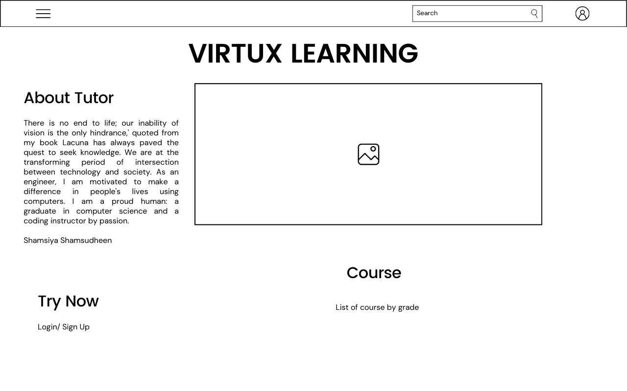

**Fig 1: Homepage Wireframe of Virtux Learning**

(Source: Developed using Canva)

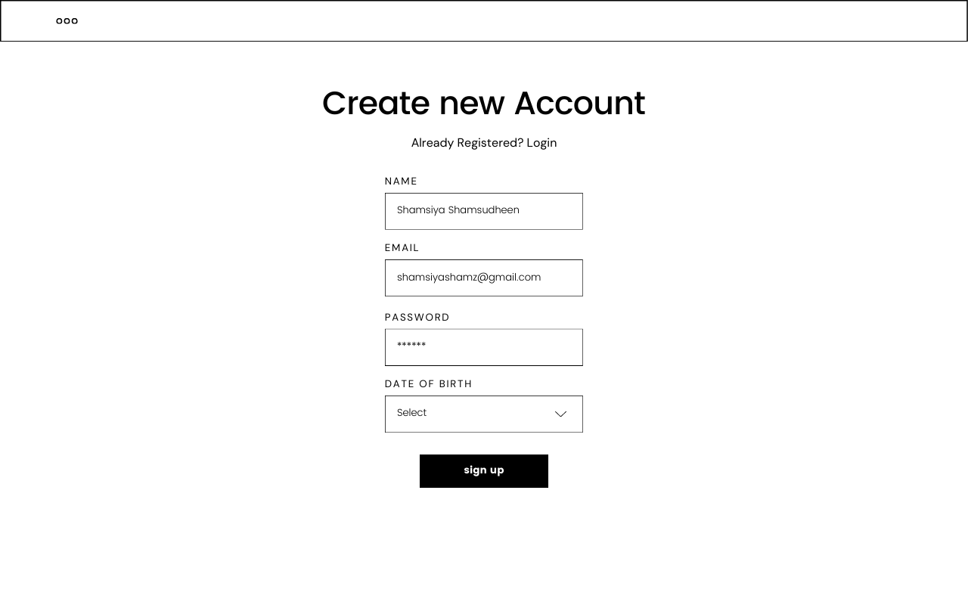

**Fig 1: Signup Wireframe of Virtux Learning**

(Source: Developed using Canva)

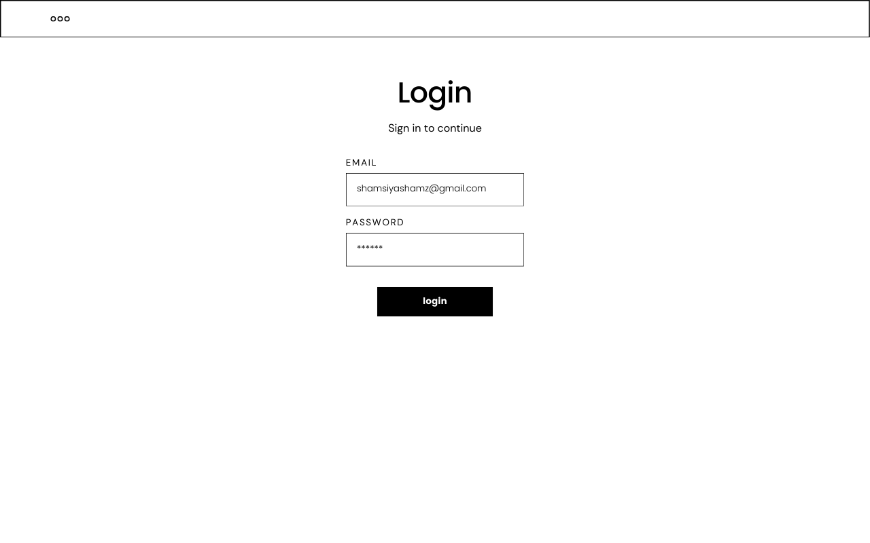

**Fig 1: Login Wireframe of Virtux Learning**

(Source: Developed using Canva)

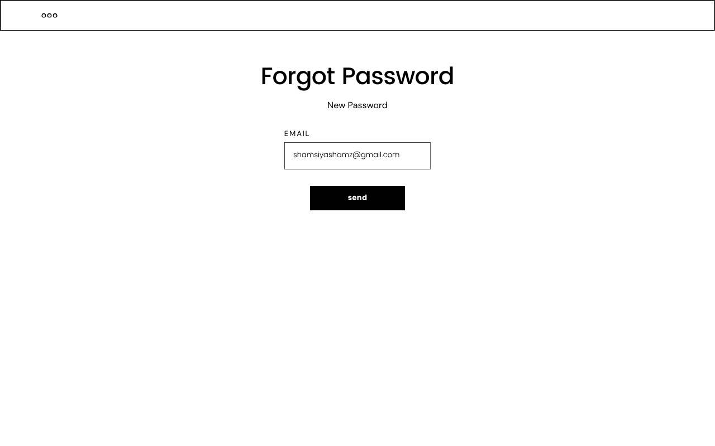

**Fig 1: Incorrect Credential Wireframe of Virtux Learning**

(Source: Developed using Canva)

## **Use Case Diagram**

This use case diagram is a graphical representation of the interactions between the elements of a virtual learning management system. It shows the different actors in the EMS, such as the super admin, system user, teacher, and student, and the various use cases they perform, such as managing courses, schedules, and students. The diagram also shows the relationships between the actors and the use cases, such as the super admin having control over all VLMS operations. At the same time, the teacher can create courses and check results. The student can check classes, take tests, and view results. This use case diagram is used to identify, clarify, and organize the requirements of the VLMS. It helps to understand how the different actors and use cases interact within the system**.**

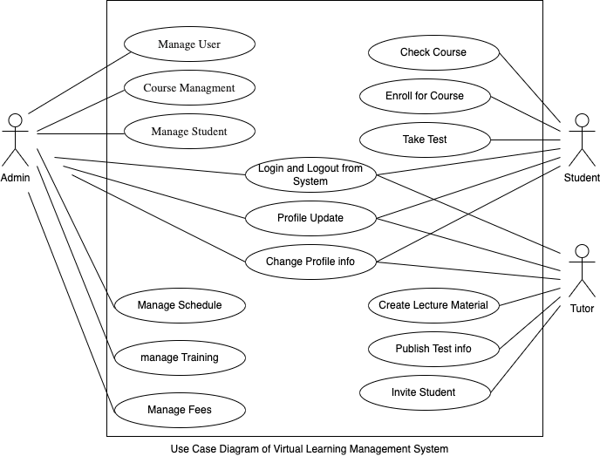

(Source: Developed using draw.io)

## **Sequence Diagram**

This is the login sequence diagram for the E-Learning Management System. The administrator can log in to their account using their credentials. Once logged in, the user can manage all operations related to durations, training, fees, students, and subjects. These pages, such as the fees, students, and subjects, are secure and can only be accessed after the user has logged in. The diagram below illustrates the login process in the E-Learning Management System. The various objects in the students, durations, training, fees and subject pages interact during the sequence. The user must verify their identity before accessing these pages.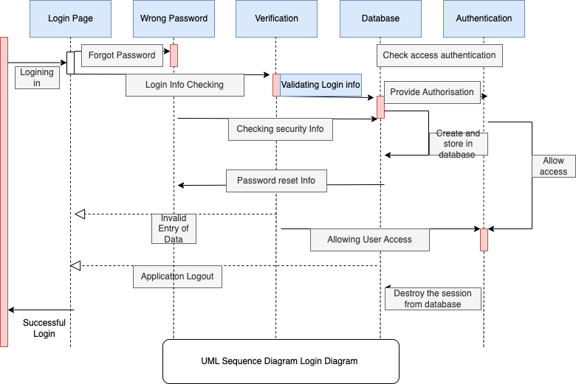

(Source: Developed using draw.io)

## **ER Diagram**

This Entity Relationship (ER) diagram represents the E-Learning Management System Entity model. The ER diagram for the Virtual Learning Management System displays the visual representation of the database tables and the relationships between entities such as students, fees, and courses. It is used to structure data and define the relationships between groups of Virtual Learning Management System functionalities.

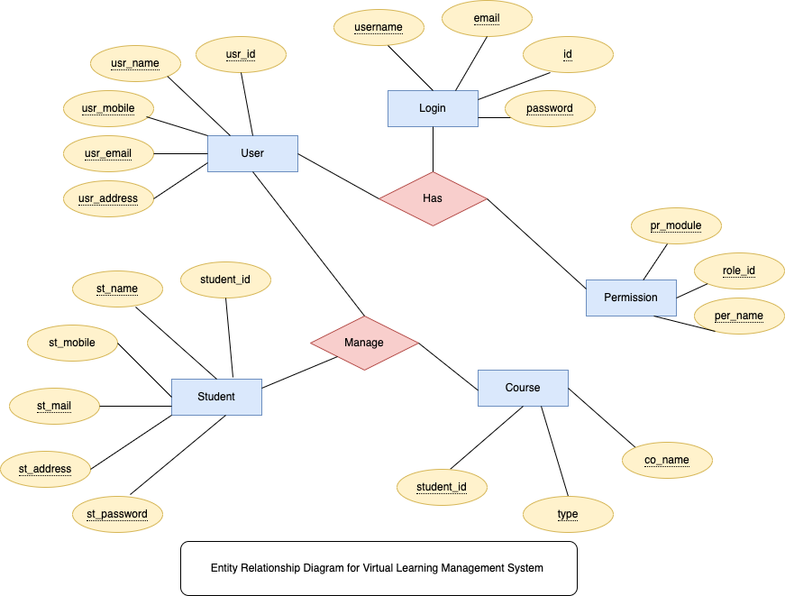

(Source: Developed using draw.io)

## **Activity Diagram**

An activity diagram for a virtual learning management system could represent the various processes and actions involved in managing and administering an e-learning platform. Some examples of activities that might be included in an activity diagram for an e-learning management system are:

* Login: This activity represents the process of a user logging into the system. It could include sub-activities such as entering a username and password and verifying the credentials.
* Enrol in a course: This activity represents the process of a user enrolling in a course. It could include sub-activities such as selecting a method, paying any necessary fees, and being added to the course roster.
* Manage courses: This activity represents the process of an administrator managing the courses offered in the e-learning platform. It could include sub-activities such as adding new classes, modifying existing techniques, and deleting courses.
* View progress: This activity represents the process of a user viewing their progress in a course. It could include sub-activities such as accessing the progress page and viewing the student's progress on assignments, quizzes, and exams.

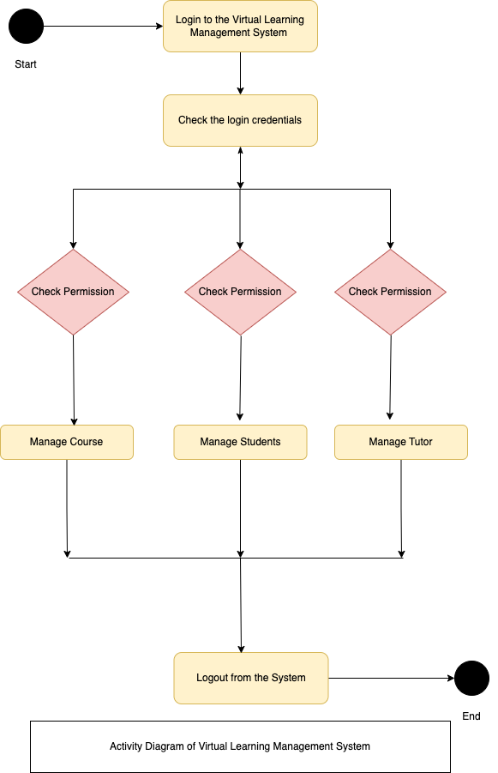

(Source: Developed using draw.io)

## **Class Diagram**

A class diagram for a virtual management system includes classes such as:

User: This class could represent the system's users, including administrators and regular users. It could consist of user ID, name, and role attributes.

Course: This class could represent the courses offered in the virtual management system. It could include attributes such as course ID, name, instructor, and description.

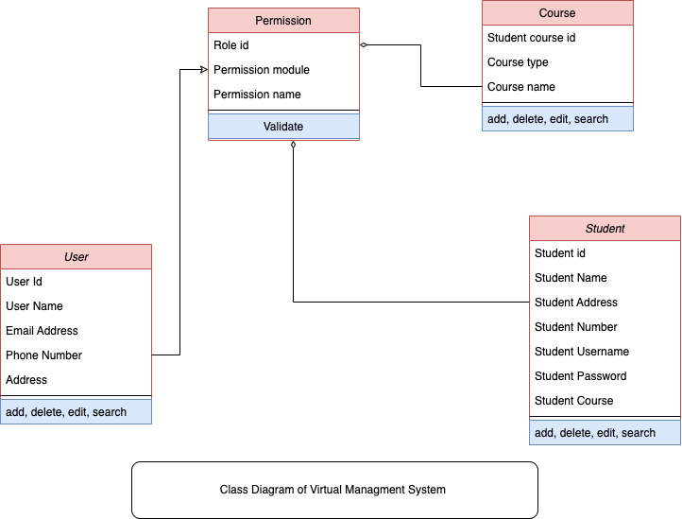

(Source: Developed using draw.io)

## **User Interface**

### **Server Connection**

XAMPP is free, open-source software that allows running a web server on the local machine. When installing XAMPP, it installs and configures Apache and MySQL servers, can use the XAMPP control panel to start/stop these servers and manage other components. Connecting to the server's files and databases can be accessed without internet connectivity.

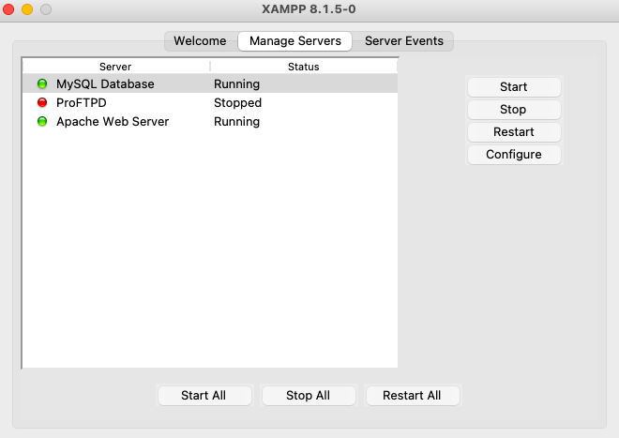

**Fig 1: Server Connection**

(Source: Developed using XAMPP)

**Database –PHPMyAdmin**

MySQL programming language is used in this database for creation, appending, and editing.

CREATE TABLE users (

userID int(11) AUTO_INCREMENT PRIMARY KEY not null,

username varchar(256) not null,

password varchar(256) not null,

roleID int(11) not null

);

INSERT INTO users (userID, email, username, password, roleID) VALUES( ‘1’, ’shamsiya’, ‘shams12345’)

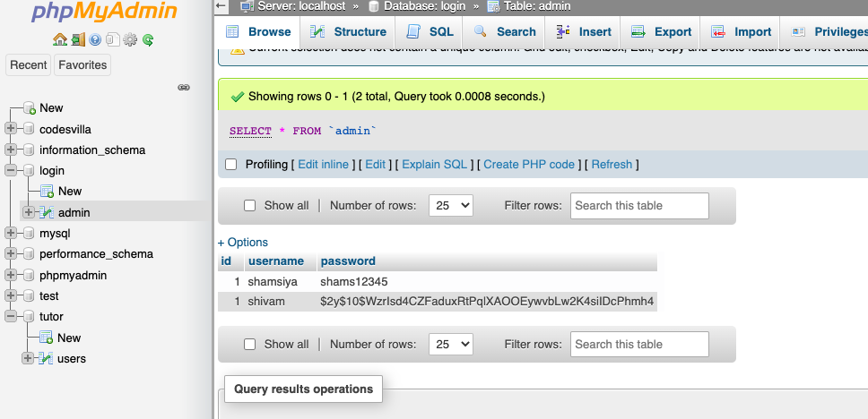

**Fig 1: Database of Virtux Learning**

(Source: Developed using localhost)

### **Website**

The home page allows users to browse the website; this device has considered interactive design principles

* The visibility is enhanced in this model with minimal design so the user can see the entire application work.
* A standardised layout to increase consistency is implemented.
* The icons used are familiar to every user, along with affordance.
* Navigating from one page of the website makes it easier to surf, while the AR implementation was given a new window using target= “blank”, hence not complicating the learners.
* Control of the VR is a bit complicated since this is a pilot model. The mouse movement is tricky and a little uneasy for first-time users.
* Feedback is provided to users when incorrect credentials are made in a dialogue box.

The below figures clearly depict the application of Virtux Learning, using programming languages (See figures 3 to 10). This application tried to bring out the emerging technology-based learning approach. Due to time, constraints building from scratch was the best challenge of Virtux Learning.

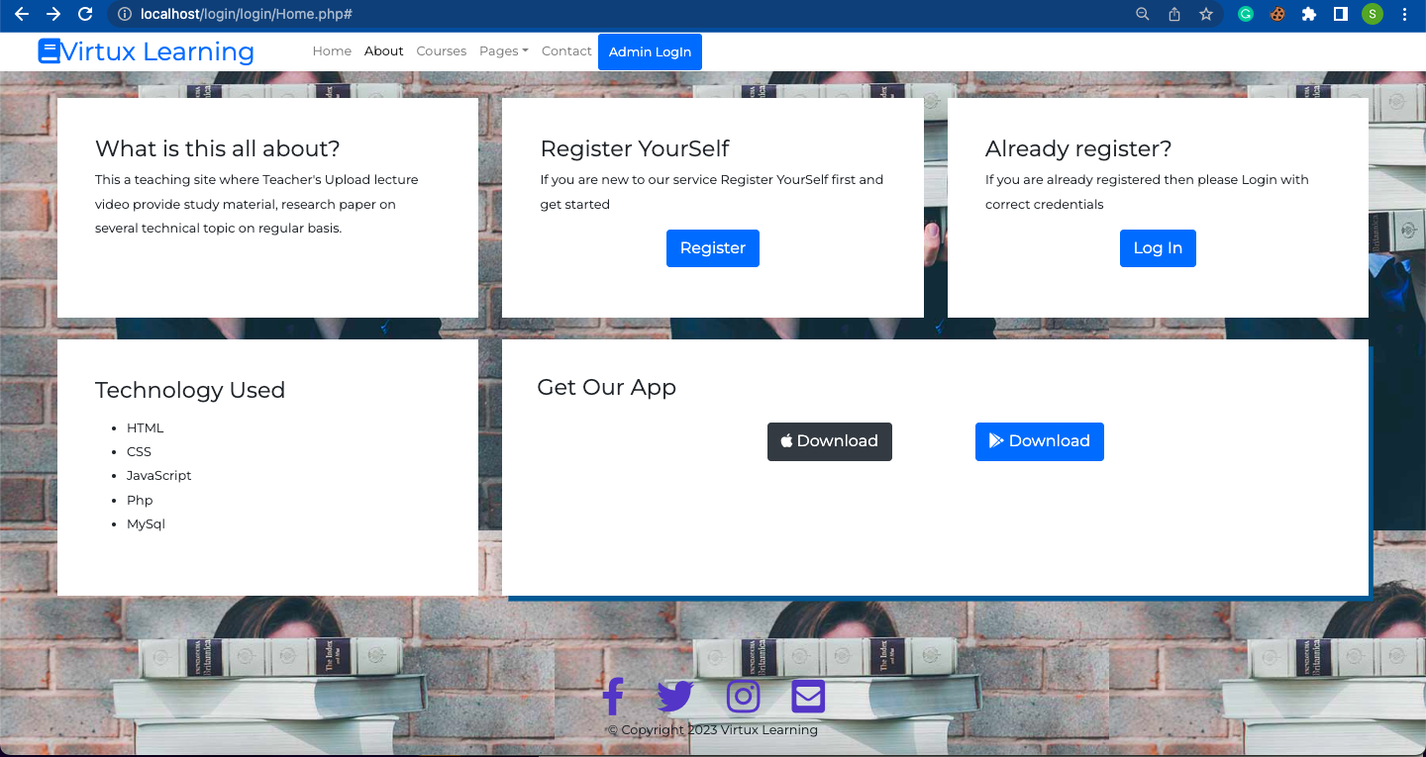

**Fig 3: Home Page of the VLMS named Virtux Learning**

(Source: Developed using Visual Studio)

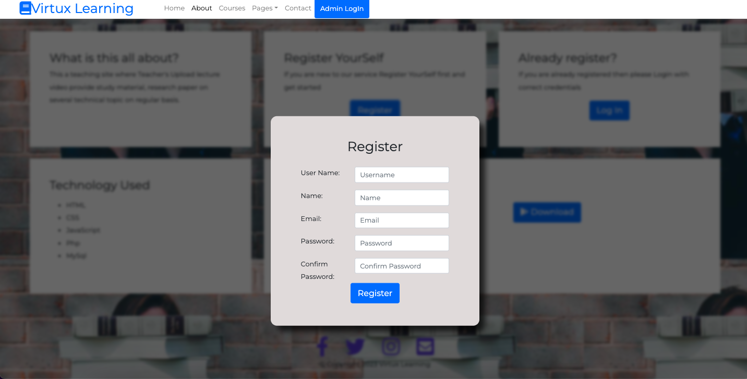

**Fig 4: SignUp Page of the Website**

(Source: Developed using Visual Studio)

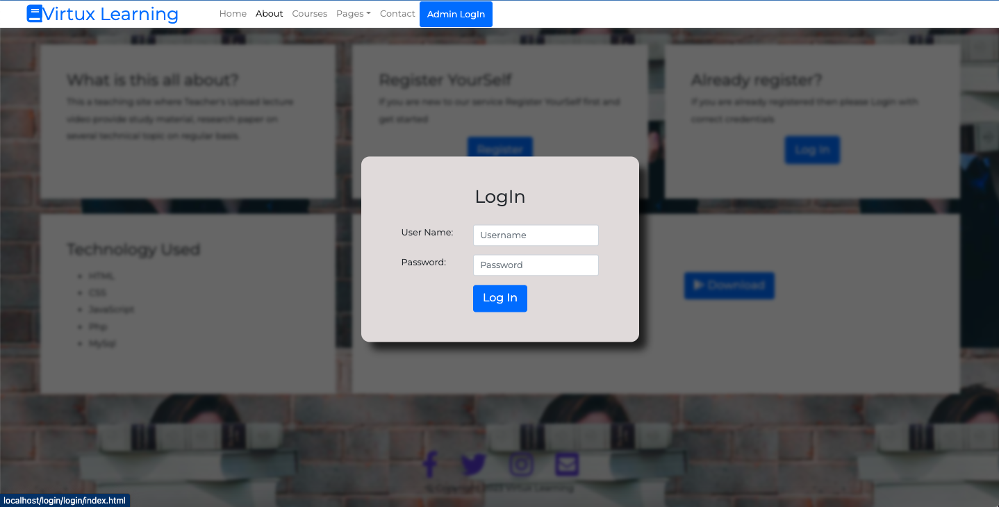

**Fig 5: Login Page Virtux Learning**

(Source: Developed using Visual Studio)

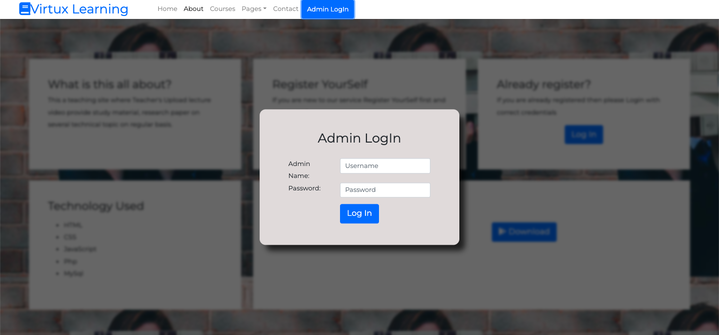

**Fig 6: Admin Page of Virtux Learning**

(Source: Developed using Visual Studio)

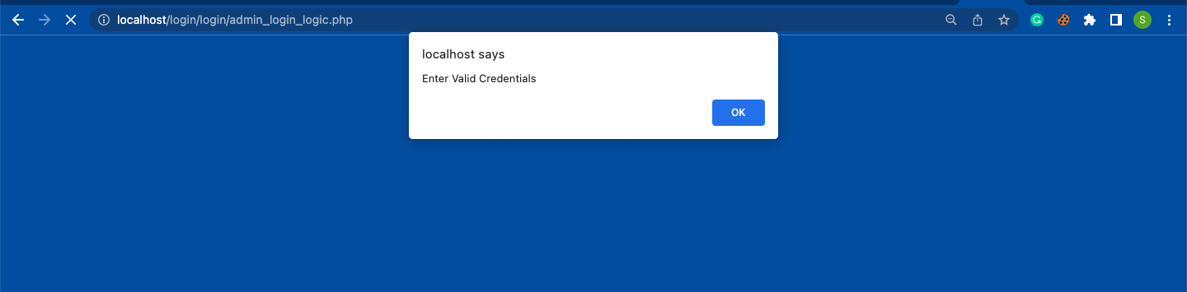

**Fig 7: Error in Credential Page of Virtux Learning**

(Source: Developed using Visual Studio)

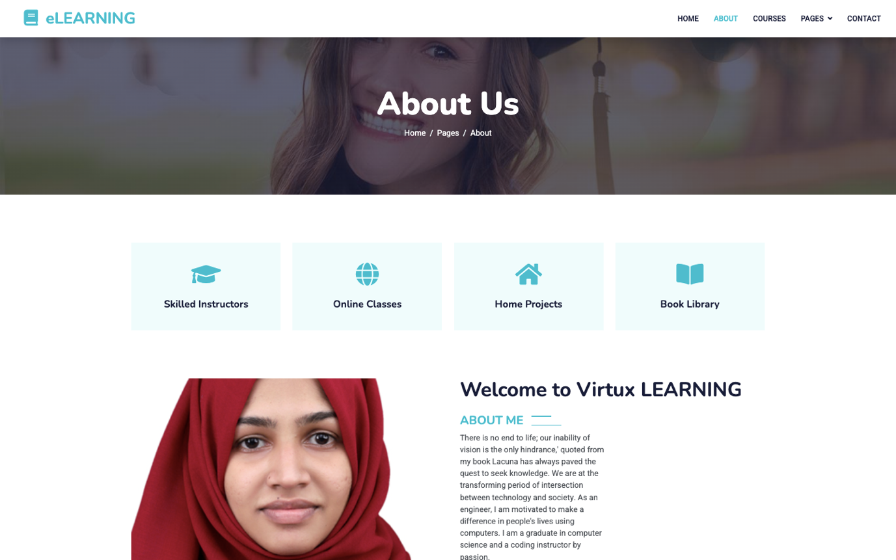

**Fig 8: About Us Webpage of Virtux Learning**

(Source: Developed using Visual Studio)

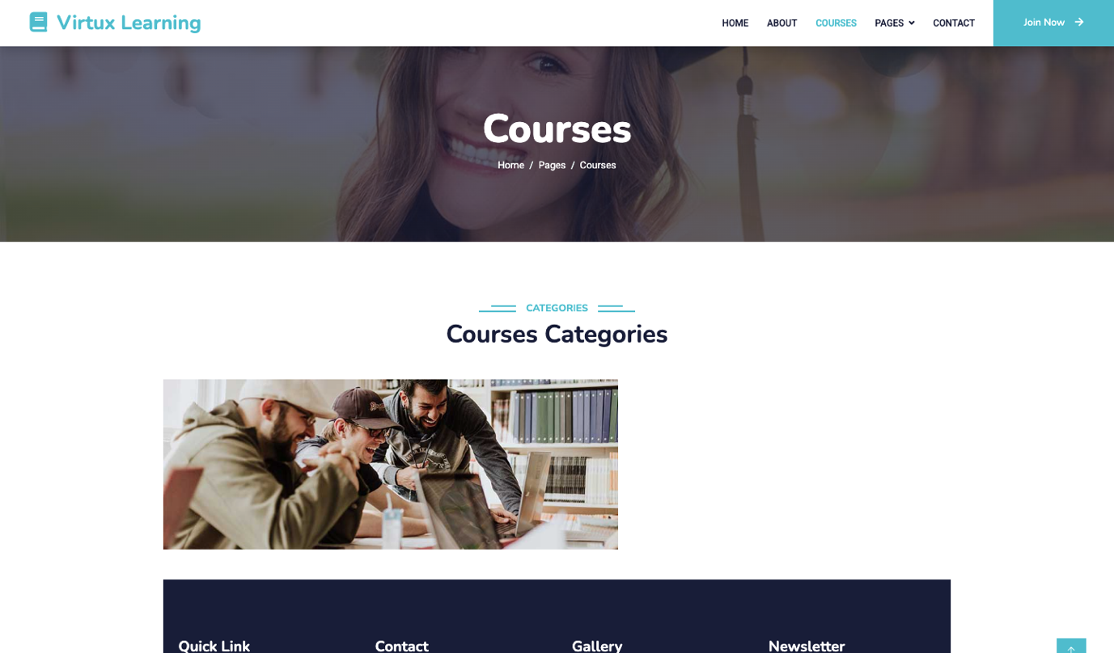

**Fig 9: Course List of Virtux Learning**

(Source: Developed using Visual Studio)

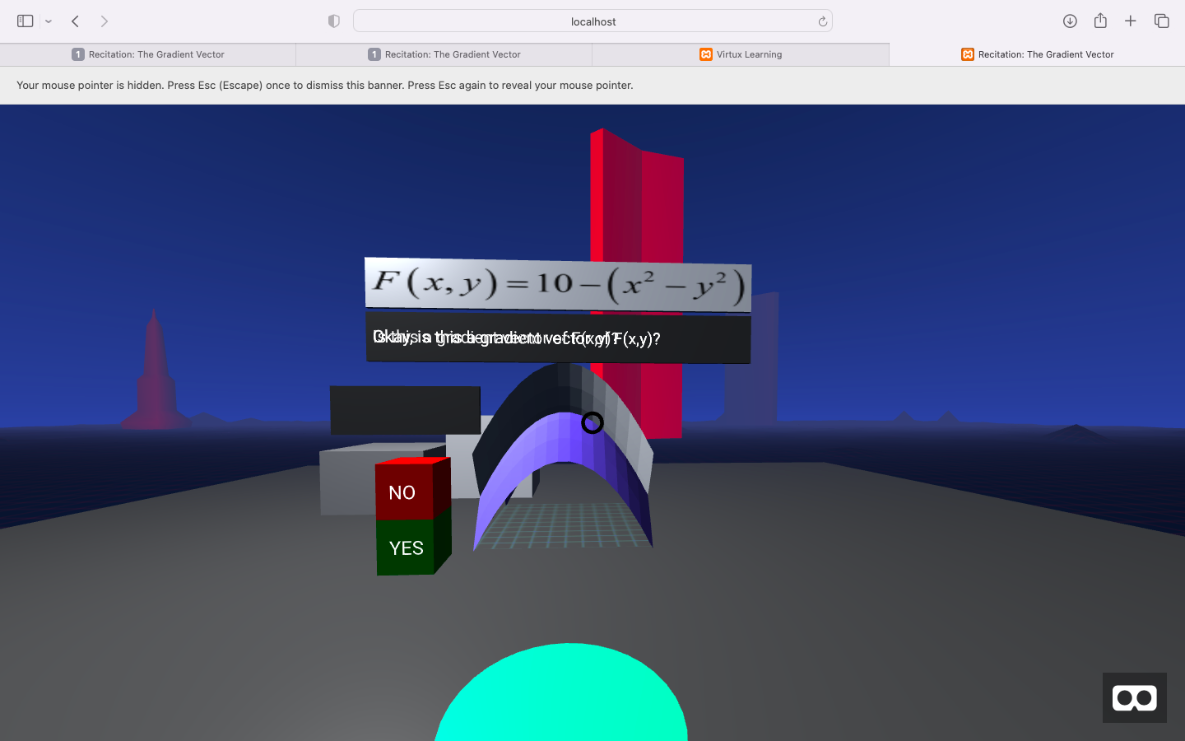

**Fig 10: Virtual Reality Base Learning Approach of Virtux Learning**

(Source: Developed using Visual Studio)

## **TESTING**

A user-centred design (UCD) approach to testing for an e-learning management system (LMS) typically involves several stages of testing, including user research, usability testing, and user acceptance testing. Usability testing: After the user research phase, the next step is to conduct usability testing to evaluate the LMS's design and user interface. This can be done using methods such as cognitive walkthroughs, usability inspections, and user testing. The goal of usability testing is to identify and fix any usability issues in the LMS to ensure that it is easy and efficient to use. For the developed system the VR is not aligned with the browser and was a bit tricky for the user (Joseph S. Dumas, 1999).

# **CONCLUSION**

The proposed model is a starting stage for implementing a virtual reality-based education system in VLMS. VR has the potential to transform education. There are currently few major tech companies in this field, providing an opportunity for new entrants to take a leading role in VR e-education. One way to monetise this idea is to develop VR learning tools and experiences that provide a unique and immersive educational experience. In addition to traditional e-learning, VR can be used for virtual tourism, allowing users to visit and explore a variety of locations beyond just Google Street Views by creating a virtual world or "metaverse." VR can also be used to create virtual classrooms and develop VR models for various courses and subjects. However, it's essential to consider the suitability of VR for a given learning environment and to ensure that learners have the necessary hardware and software to participate in VR-based learning experiences. Various issues are prevailing in the system as VR needs to be developed for a full-fledged learning environment. And there needs to be a payment system added for the courses, and a well-organised course module implementation will make the design stand out.

# **BIBLIOGRAPHY**

1. Aziah Alias, N. & Marzuki Zainuddin, A., 2005. Innovation for Better Teaching and Learning: Adopting the Learning Management System. *Malaysian Online Journal of Instructional Technology,* August, 2(2), pp. 27-40.
2. Arsyad, N., Rahman, A. & Ahmar, A. S., 2017. Developing a self-learning model based on open-ended questions to increase the students’ creativity in calculus. *Global Journal of Engineering Education,* May.19(2).
3. Garrett, J. J., 2002. *The Elements of User Experience: User-Centered Design for the Web.* New Riders: s.n.
4. Tsai, B.-Y., Stobart, S., Parrington, N. & Thompson, J., 1997. Iterative Design and Testing within the Software Development Life Cycle. *Software Quality Journal,* December.pp. 295-310.
5. Salza, P. a. M. P. a. F. F., 2019. Agile Methodologies in Education: A Review: Bringing Methodologies from Industry to the Classroom . In: *Agile and Lean Concepts for Teaching and Learning.* s.l.:Springer, pp. 25-45.
6. Joseph S. Dumas, J. C. R., 1999. *A Practical Guide to Usability Testing.* ExeterUnited: Intellect Books.
7. Eze, S. a. C.-E. V. a. B. A., 2020. Factors influencing the use of e-learning facilities by students in a private Higher Education Institution (HEI) in a developing economy. *Humanities and Social Sciences Communications ,* October, Volume 7, p. 133.
8. Viska Mutiawani, J. J., 2015. *Developing e-learning application specifically designed for learning introductory programming ,* s.l.: s.n.